

SNS COLLEGE OF ENGINEERING
Kurumbapalayam (Po), Coimbatore – 641 107
AN AUTONOMOUS INSTITUTION
Approved by AICTE, New Delhi and Affiliated to Anna University, Chennai

A MINI PROJECT REPORT

On

RELAX MATE

in partial fulfilment for the award of the
degree of

BACHELOR OF ENGINEERING

in
COMPUTER SCIENCE AND DESIGN

Submitted by
Brijesh S R (713323CD006) Kirthik Kumar S (713323CD024) Koshika T (713323CD025) Mohammed Afsal B (713323CD029)

Academic year 2024-2025

BONAFIDE CERTIFICATE
Certified that this project “Relax Mate” is the bonafide work of “Brijesh S R (713323CD006), Kirthik Kumar S (713323CD024), Koshika T (713323CD025), Mano Prashanth R (713323CD027), Mohammed Afsal B (713323CD029)” and they had carried out the project work under my supervision.

SIGNATURE
Dr.B.Anuradha, M.S., Ph.D., Associate Professor & Head,
Department of Computer Science and Design, SNS College of Engineering,
Coimbatore -641107.

SIGNATURE
Ms.A.Sunanda Christy, B.E., M.E.,
Assistant Professor & Project Coordinator Department of Computer Science and Design, SNS College of Engineering,
Coimbatore -641107.

Acknowledgement

We extend out heart-felt and sincere thanks to the Management of SNS College of Engineering for providing us with all sorts of support for the completion of this project. We record our obligation to Dr.S.N. Subramanian, Chairman, SNS Group of Institutions & Industries and Dr.Nalin Vimal Kumar S, Technical Director, SNS Technical Institutions and Dr.V.P.Arunachalam, Director, SNS College of Technology and Dr.S.Charles, Principal, SNS College of Engineering and Dr.R.Sudhakaran, Vice Principal, SNS College of Engineering for their guidance and sustained encouragement for the successful completion of this project. We are highly grateful and whole heartedly express our gratitude to Dr.B.Anuradha, Associate Professor and Head, Department of Computer Science and Design, for her expert guidance, suggestions, and active encouragement for the fulfillment of the project work.
We extend our deep sense of gratitude to Ms.A.Sunanda Christy, Project Coordinator, Assistant Professor, Department of Computer Science and Design for her significant guidance and her persistent help in all our end favours. We also record our deep sense of indebtedness to our project Guided by Ms.A.Sunanda Christy, for her unstinted support and guidance throughout this project. Her continuous motivation and minute to minute guidance with timely assistance rendered us to come out the project with flying colours. It is her immediate counselling, solving all the problems that arise during completion of this project successfully. We also take pleasure in expressing our humble note of gratitude to other Faculty member, non-teaching faculty members, parents, friends and our juniors for providing their moral support in successful completion of this project work.

TABLE OF CONTENT

S.NO. | TOPIC | PAGE NO.
1. | Abstract | 1
2. | Industrial Vertical & Domain Technology | 2
3. | Empathy | 4
4. | Define | 7
5. | Ideate | 8
6. | Prototype | 11
7. | Testing & Deployment | 13

Abstract

The Relax Mate project addresses the pervasive issue of stress in modern society, which affects individuals across various demographics. As stress levels rise due to academic pressures, professional demands, and personal life events, traditional stress relief methods such as exercise, meditation, and therapy may not always be accessible or practical. Recognizing these limitations, the Relax Mate initiative proposes an innovative platform designed to provide effective stress relief through engaging and interactive activities. At the core of the Relax Mate solution is a multi-faceted approach that combines creative expression with emotional comfort. This artistic activity is complemented by the integration of AI-generated baby photos, which evoke positive emotional responses and contribute to an uplifting experience. Additionally, the platform incorporates soothing music and positive affirmations, further enhancing the user's emotional well-being. The design of the Relax Mate platform prioritizes user-friendliness and accessibility, ensuring that individuals of all ages can benefit from its features. By fostering an environment where users can express their creativity and engage in mindfulness practices, the project empowers individuals to take control of their mental health.
In conclusion, the Relax Mate project presents a comprehensive solution to stress management by integrating creative activities with emotional support mechanisms. By addressing the limitations of traditional stress relief methods and offering a versatile platform tailored to diverse preferences, Relax Mate aims to promote mindfulness and positive emotions among its users. This innovative approach not only seeks to alleviate stress but also fosters a proactive mindset towards mental health, making it a valuable resource in today’s fast-paced world.

Industrial Vertical and Domain Technology

Health Care:

The project is positioned within the healthcare industry, with a focus on mental health and stress relief. As stress continues to be a leading contributor to various mental and physical health issues, there is an increasing demand for innovative solutions that address this growing concern. The platform offers a modern approach to mental well-being by combining creative expression and emotional comfort, two proven methods for alleviating stress. Users can engage in symmetry drawing, which is shown to promote mindfulness, relaxation, and focus. The addition of AI-generated baby photos triggers positive emotional responses, creating a therapeutic environment that promotes happiness and calm. Furthermore, the integration of soothing music and positive affirmations ensures that users’ emotional states are nurtured during their interaction with the platform. By targeting mental health, the project aligns with the healthcare industry’s growing emphasis on preventive care and self-managed wellness. Traditional healthcare methods for stress relief, such as therapy or medication, can be costly, inaccessible, or time-consuming for many individuals. This platform offers an accessible alternative, empowering users to manage stress and anxiety at their own pace. The healthcare industry continues to evolve, and this platform provides a fresh, technology-driven solution that supports holistic well-being and mental resilience.

IOT (Internet of things):

This project leverages the power of IoT (Internet of Things) to create an engaging, user-driven platform that offers a personalized approach to stress relief and mental well-being. While the website does not calculate or process data in real time, it provides users with a variety of customizable features designed to support emotional health. Users can choose from different soothing music tracks, adjust the complexity of symmetry drawing exercises, and control the timing of positive affirmations to suit their preferences. By allowing users to engage with these elements, the platform fosters mindfulness and relaxation in a way that feels intuitive and adaptable to individual needs. Whether users are looking for a calming soundtrack to help them focus or prefer simple, repetitive drawing exercises to promote relaxation, the platform offers a versatile suite of options. The integration of positive affirmations adds an additional layer of emotional support, helping to uplift the user's mood and encourage a more positive mindset. While the platform doesn’t rely on complex data analysis or real-time monitoring, it empowers users to tailor their experience, giving them greater control over their stress relief activities. This approach creates a personalized, accessible, and soothing environment for mental wellbeing.

Chapter 1

Empathy

An empathy map is a collaborative tool used to better understand a user's thoughts, feelings, behaviors, and needs. It provides a visual representation of a user's experiences, helping teams empathize with their challenges and motivations. By focusing on what the user says, thinks, does, and feels, the map captures key insights into their perspective. This process not only aids in identifying pain points and desired outcomes but also supports the creation of user-centered solutions. Empathy maps are widely used in design thinking, product development, and customer research to ensure a deeper connection with the user.
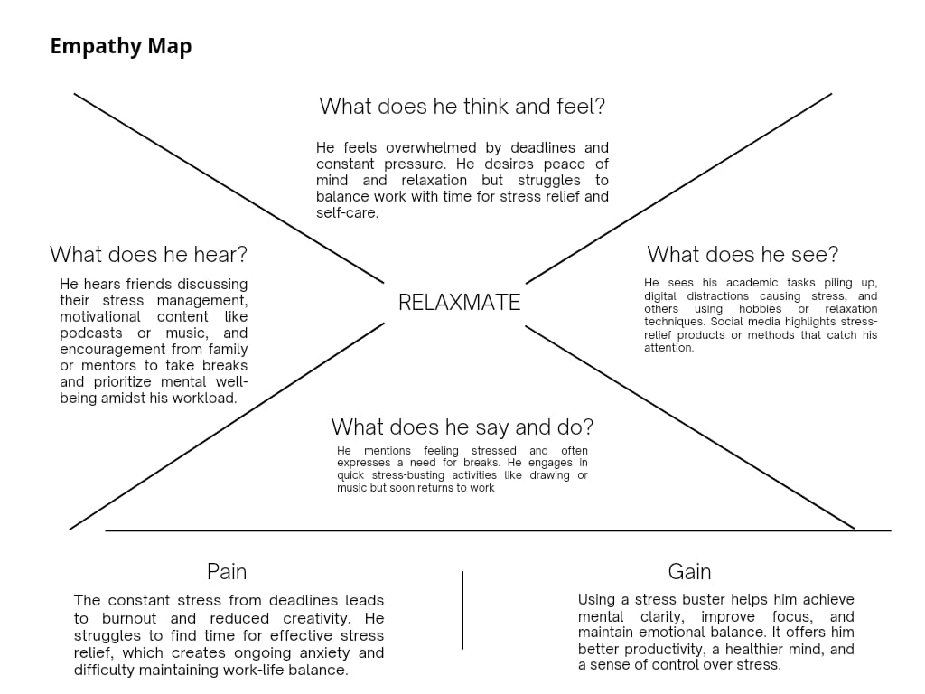
Fig.1.1 Empathy map

Says:
He often verbalizes his feelings of being stressed and overwhelmed by deadlines and responsibilities. He mentions a desire to take breaks and engage in stress-relief activities like listening to music or drawing but admits that these moments are brief and inconsistent. He frequently discusses his struggle to maintain a balance between work and relaxation, sharing how challenging it is to prioritize self-care. Despite acknowledging the importance of managing stress, he often states that he feels compelled to return to work quickly, emphasizing his focus on productivity even at the expense of his mental well-being.

Thinks:
He feels overwhelmed by the constant pressure of deadlines and the struggle to maintain balance. He desires peace of mind and effective ways to manage stress but finds it challenging to prioritize self-care amidst his busy schedule. His thoughts often revolve around achieving a sense of control over his workload while maintaining his mental well-being. He considers adopting techniques for relaxation and efficiency but feels conflicted about stepping away from his responsibilities. This inner tension leads him to frequently ponder how to improve his focus, reduce anxiety, and find a sustainable way to balance work with personal care.

Does:
He engages in brief stress-relief activities, such as listening to motivational podcasts, music, or trying creative outlets like drawing. He occasionally takes advice from friends, family, or mentors about prioritizing self-care and managing stress. Despite these efforts, he often returns to his academic tasks quickly, feeling the pressure of deadlines. He notices stress-relief products or techniques on social media and considers incorporating them but struggles to fully commit due to a lack of time or focus. His actions often reveal a tendency to prioritize productivity over consistent relaxation, leading to a cycle of incomplete stress management.

Feels:
He feels overwhelmed and burdened by the constant pressure of deadlines and an ever-increasing workload. This leads to anxiety and a sense of helplessness as he struggles to maintain a balance between productivity and self-care. The distractions caused by digital media and the piling academic tasks amplify his stress, leaving him emotionally exhausted. He also feels a deep desire for peace of mind and relaxation but finds it challenging to prioritize these amidst his responsibilities. Despite brief moments of relief through hobbies or motivational content, he often feels frustrated by his inability to sustain a sense of calm and control.

Chapter 2

Define

The project, Relax Mate, focuses on addressing the increasing challenges of stress and mental fatigue faced by individuals, particularly students and professionals juggling heavy workloads and tight deadlines. In today’s fast-paced world, maintaining a healthy work-life balance and emotional well-being has become a significant concern. The project aims to design an innovative stress-management solution that promotes relaxation, mental clarity, and improved productivity.
Relax Mate envisions creating a product or platform that integrates relaxation techniques with practical tools for stress relief. This could include features such as guided mindfulness sessions, interactive exercises, motivational content, and personalized suggestions based on user preferences. Social media trends and insights from user behavior studies will be incorporated to ensure the solution is engaging and relevant.
The ultimate goal of this project is to empower users to manage their stress effectively while improving their overall quality of life. By prioritizing user-centered design and thorough research, Relax Mate aims to create a meaningful impact in the area of mental health and well-being. This project aligns with modern approaches to tackling stress, blending technology, design, and empathy to create a product that truly caters to its users' needs.
Relax Mate is more than a product—it is a step toward fostering a culture of mental wellness in today’s demanding world.

Chapter 3

Ideate

The project Relax Mate seeks to address the growing need for accessible and effective stress management in today’s fast-paced world. Stress, particularly from work, school, or daily life, can negatively impact productivity, health, and overall well-being. Relax Mate is designed as a web-based solution that combines interactive features to help users relax, manage stress, and improve their emotional balance. Using modern web technologies such as HTML, CSS, JavaScript, and JSON, the platform offers a user-friendly and engaging experience with various techniques like symmetry drawing, soothing music, baby photos, and positive affirmations.

Symmetry Drawing:
One of the core features of Relax Mate will be symmetry drawing, a technique known for its calming effects. The concept behind symmetry art involves creating balanced, repeating patterns, often seen in mandalas or geometric shapes. Engaging in such drawing activities promotes mindfulness and reduces anxiety by helping users focus on the task, creating a meditative experience. Relax Mate will provide a digital drawing tool where users can interactively create symmetrical designs. This will not only allow users to express their creativity but also calm their mind and reduce stress. JavaScript will be used to enable the drawing functionality, while CSS will style the drawing canvas for an intuitive and pleasant user experience.

Baby Photos:
Research has shown that looking at cute images, such as baby photos, can have an emotional soothing effect, triggering positive emotions that help alleviate stress. Relax Mate will feature a curated collection of baby photos to evoke feelings of joy and warmth. These images will be carefully selected to ensure they help users reconnect with their positive emotions during moments of stress. The baby photos will be displayed in a pleasant, easy-to-navigate gallery, allowing users to engage with the content while experiencing a sense of emotional relief.

Positive Affirmations:
Positive affirmations are a powerful tool for managing stress and improving mental health. By reinforcing optimistic thoughts, affirmations help users combat negative mental patterns. Relax Mate will feature daily positive affirmations such as “I am in control of my stress,” “I am capable of achieving my goals,” or “I choose peace over anxiety.” These affirmations will be dynamically generated using JSON to ensure they are personalized based on the user’s preferences and needs. JavaScript will handle the interaction, allowing users to read a new affirmation each day, helping them maintain a positive mindset.

Soothing Music:
Music has long been recognized for its therapeutic properties. Relax Mate will include a library of soothing music tracks, such as instrumental tunes, ambient soundscapes, and nature sounds, all designed to help users relax and calm their minds. Users will have the option to play these tracks while engaging with other features on the site. JavaScript will be

responsible for controlling music playback, including play, pause, and volume adjustments. The music will be embedded into the website, providing seamless integration with the user interface.

Technological Implementation:
The app will be built using HTML for the basic structure of the website, CSS for styling and ensuring a calming, visually appealing design, and JavaScript for interactivity. JSON will be used to manage data such as user preferences, session data, and content like affirmations and music tracks. This combination of technologies will create a seamless, engaging, and effective platform for users seeking stress relief.

Chapter 4

Prototype

The prototype for Relax Mate serves as a tangible representation of the envisioned stress-relief web application. It showcases the platform’s core features, including symmetry drawing, soothing music, baby photo galleries, and positive affirmations, all designed to promote relaxation and mental well-being. Built using HTML, CSS, JavaScript, and JSON, the prototype highlights the user-friendly interface and interactivity that makes Relax Mate accessible to a broad audience. The prototype offers a glimpse into the personalized experience the app aims to provide, enabling users to explore various stress-relief techniques in a seamless, engaging environment. This serves as a foundation for future development and refinement.

Program:
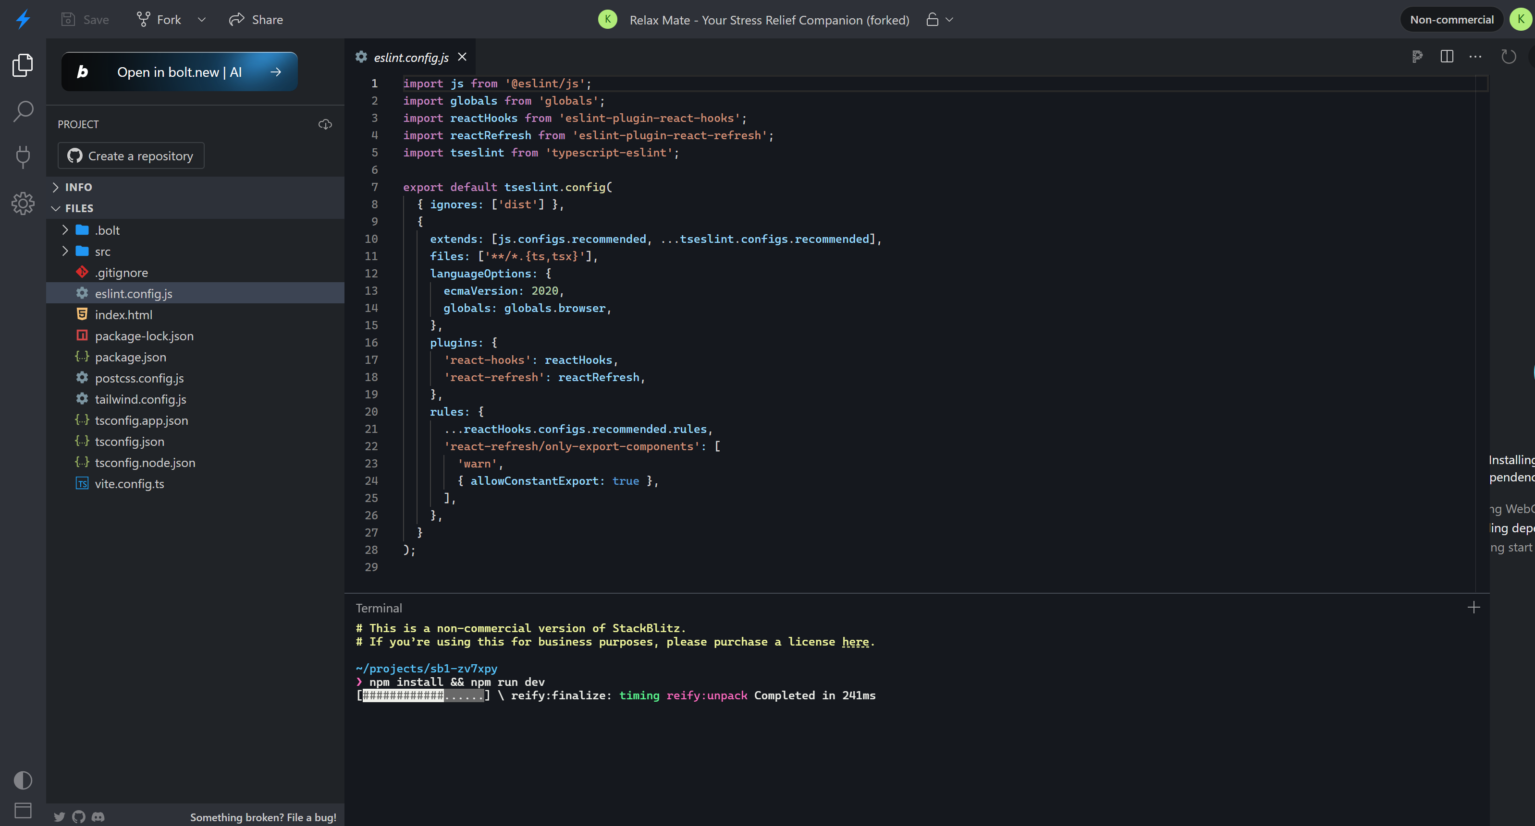
Fig.4.1 Program code

Prototype:
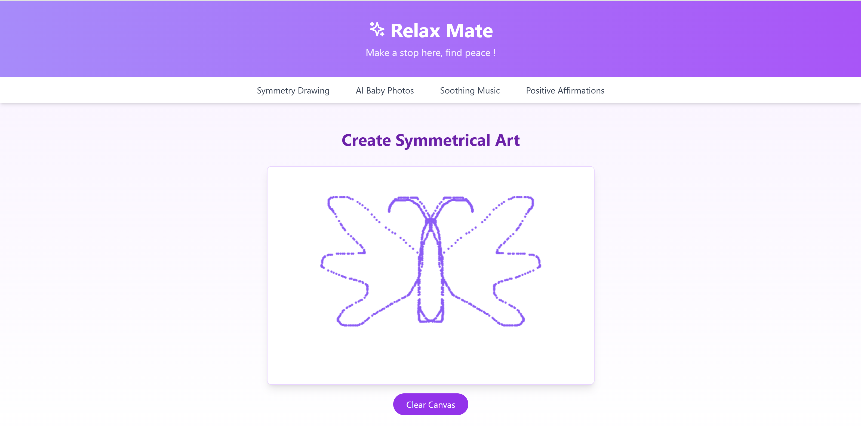
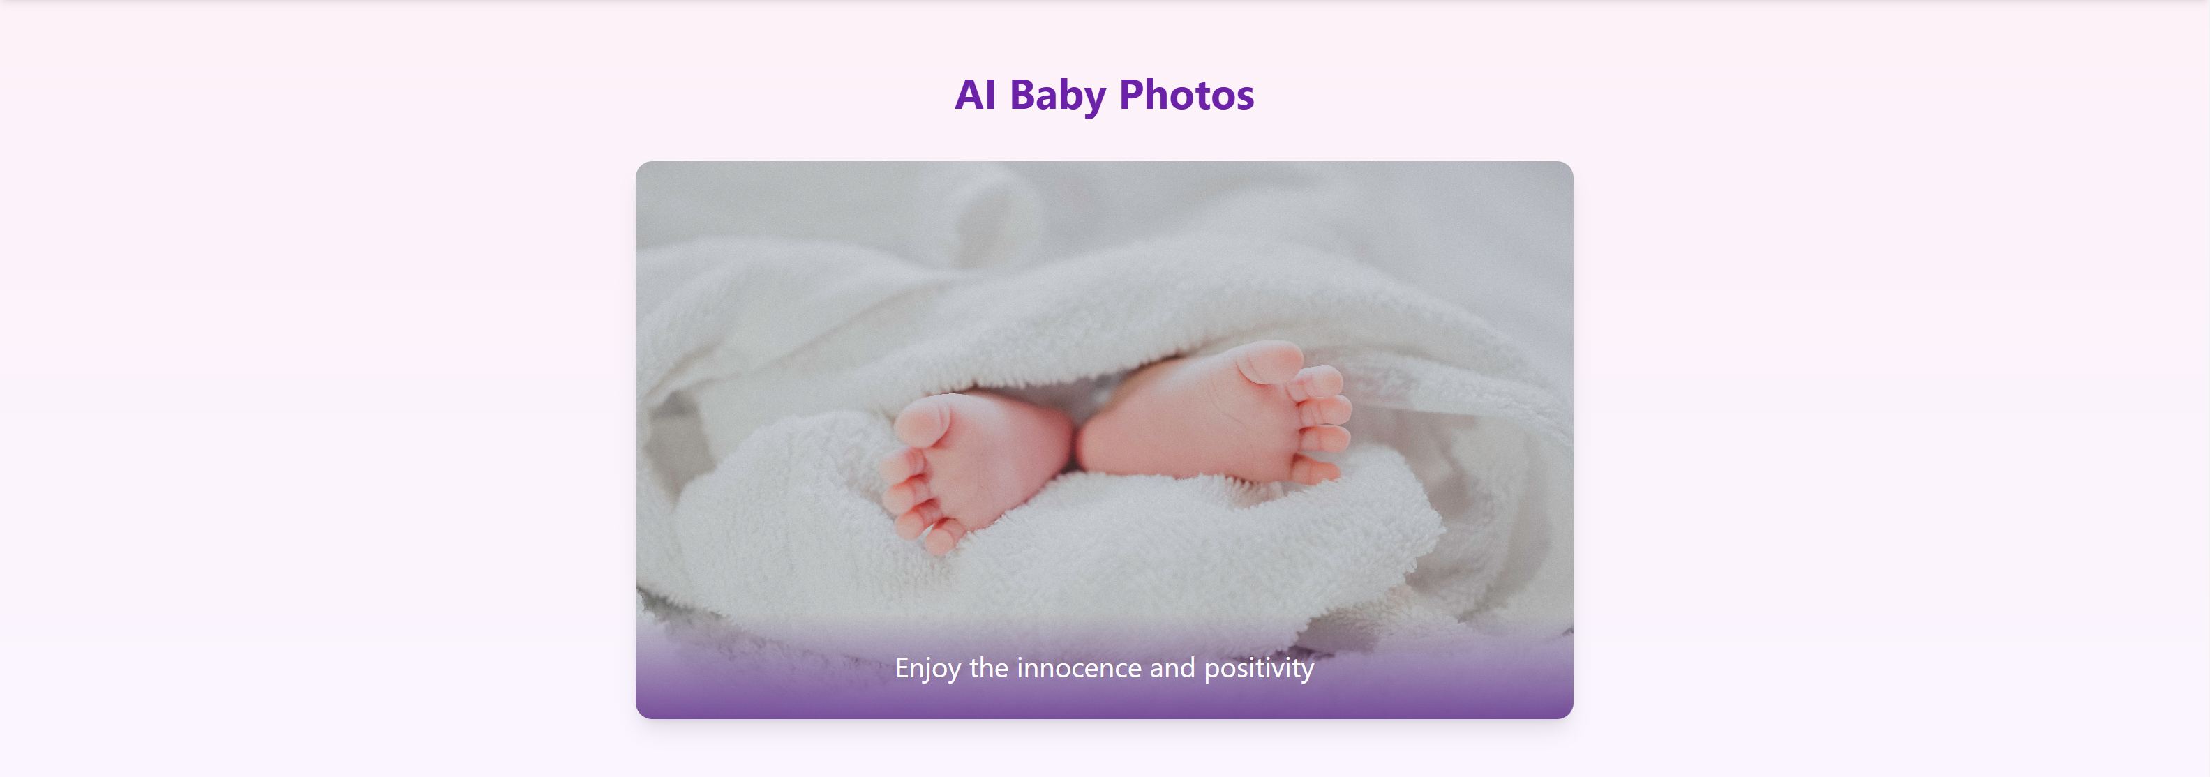
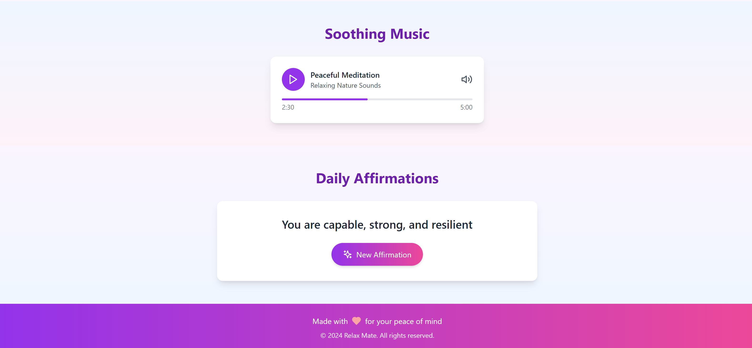
Fig.4.2 Prototype

Chapter 5

Testing & Deployment

Data Testing:
The prototype data testing phase for Relax Mate focuses on evaluating the functionality and user experience of its key features, such as symmetry drawing, soothing music, baby photo galleries, and positive affirmations. Specifically, for the symmetry drawing tool, testing involves verifying the responsiveness and accuracy of the drawing canvas, ensuring smooth creation of symmetrical patterns. Feedback will be collected to assess usability, including the effectiveness of the tool in promoting relaxation. Other components, like music playback and affirmation displays, will be tested for seamless integration and personalization. This phase ensures all features perform optimally, providing a stress-free and engaging user experience.

Real-time Testing:
The prototype testing for Relax Mate focuses on evaluating the real-time functionality and effectiveness of its core features, such as symmetry drawing. The aim is to ensure smooth interactivity, user engagement, and stress-relief impact. Users will test the symmetry drawing tool by creating patterns, while the system's responsiveness and accuracy in generating symmetrical designs will be monitored. Feedback on the calming effects of the activity will also be collected. Additional features like positive affirmations, baby photos, and soothing music will be assessed for seamless integration and user satisfaction. This testing phase ensures the prototype meets its goals of stress relief and user ease.

Conclusion:
In conclusion, Relax Mate is an innovative and thoughtfully designed web application aimed at providing a holistic approach to stress relief through interactive and personalized features. Stress has become an unavoidable part of modern life, often affecting productivity, creativity, and emotional well-being. Through features such as symmetry drawing, soothing music, positive affirmations, and a curated gallery of baby photos, Relax Mate offers users a comprehensive toolkit to combat stress effectively. By integrating these elements into a single platform, the project ensures accessibility, ease of use, and a meaningful user experience.
Real-time prototype testing will play a critical role in validating the effectiveness of the features and gathering user feedback. This iterative process ensures that the final product not only meets technical standards but also fulfils its purpose of stress management. The testing phase will assess responsiveness, interactivity, and the emotional impact of the activities, leading to continuous improvements.
Overall, Relax Mate stands out as a powerful solution for stress relief, combining creativity, positivity, and sensory stimulation in an engaging platform. By addressing the diverse needs of users, the project contributes to improving mental health and emotional balance. The success of Relax Mate lies in its ability to integrate technology with stress-relief practices, providing a valuable tool for individuals to manage stress effectively and enhance their overall quality of life. This project demonstrates the potential of technology-driven solutions in fostering well-being and mental clarity.

Future Enhancements:
As part of Relax Mate’s ongoing development, several future enhancements are envisioned to make the platform more dynamic, personalized, and impactful for stress management. One key improvement involves integrating innovative stress-monitoring technologies. By incorporating biometric sensors or wearable device compatibility, the app can measure real-time stress indicators such as heart rate variability, or breathing patterns. This data can be analysed to assess stress levels and adapt the platform’s approach accordingly, offering highly personalized recommendations instead of traditional, one-size-fits-all methods.
For example, during periods of heightened stress, Relax Mate could automatically shift to more calming activities such as playing specific nature sounds or guided meditations, while during moderate stress, it might suggest engaging activities like symmetry drawing or motivational affirmations. This adaptive functionality ensures that users receive interventions tailored to their current state of mind and physical well-being.
To further enhance the app's utility, stress-relief gamification could be introduced. This could involve interactive challenges or rewards for consistent usage, encouraging users to engage in stress-management practices regularly. The platform may also expand its database to include AI-driven mental health insights, empowering users to understand their stress triggers and adopt better coping strategies.
These enhancements aim to establish Relax Mate as a cutting-edge stress-relief solution, continually adapting to users' needs while moving beyond traditional methods to offer innovative, technology-driven stress management.

External Source
https://www.verywellmind.com/mandala-coloring-and-relaxation-5191275
https://www.sciencedaily.com/releases/2012/10/121003204736.htm
https://www.psychologytoday.com/us/blog/urban-survival/201802/how-positive-affirmations-can-help-you
https://pubmed.ncbi.nlm.nih.gov/30001163/
https://www.ncbi.nlm.nih.gov/pmc/articles/PMC7714940/
https://www.frontiersin.org/articles/10.3389/fpsyg.2018.01122/full
https://www.jmir.org/2021/3/e20086/

